Experiment No: 4

Experiment Name: Information Gathering Using theHarvester

Aim
To gather publicly available information about an authorized target domain using theHarvester for reconnaissance purposes.

Procedure
- Open Kali Linux and launch the Terminal.
- Check whether theHarvester is installed:
- Select an authorized domain for the experiment
- Run theHarvester with a search engine/source
- Wai for theHarvester to collect publicly available information.
- Observe the results displayed in the terminal.
- Record the discovered information such as email addresses, hostnames, and subdomains, if available.
- The results can be saved for later analysis if required.

output

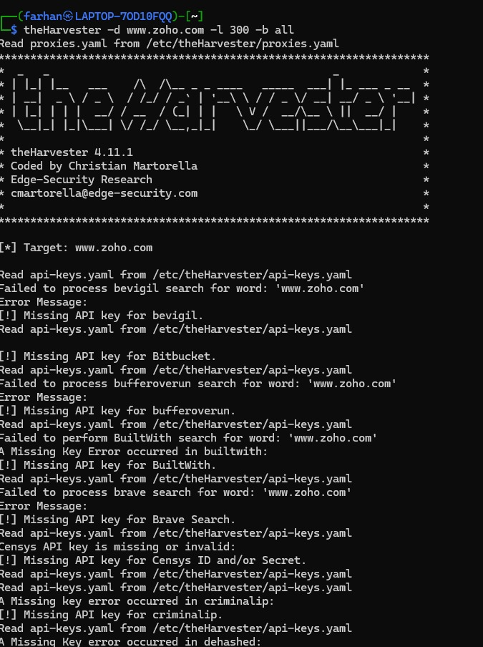

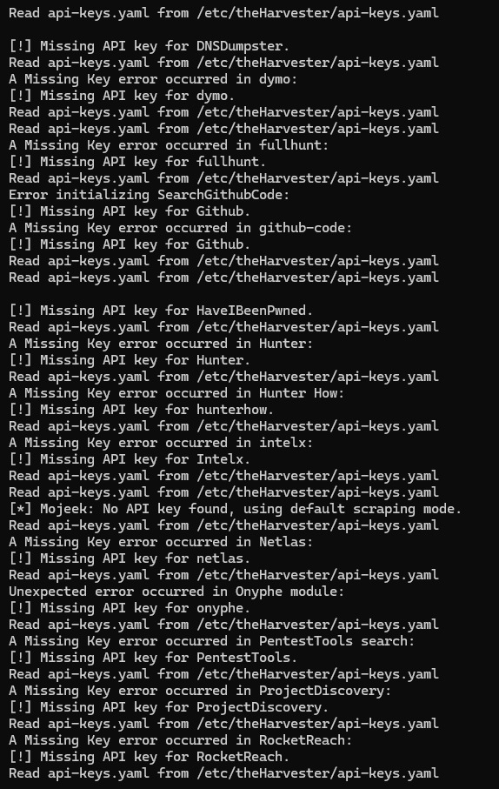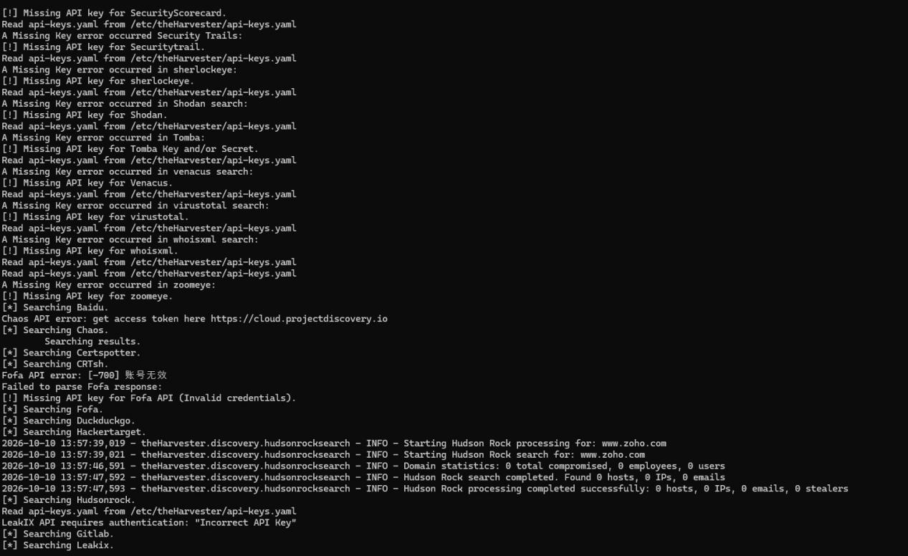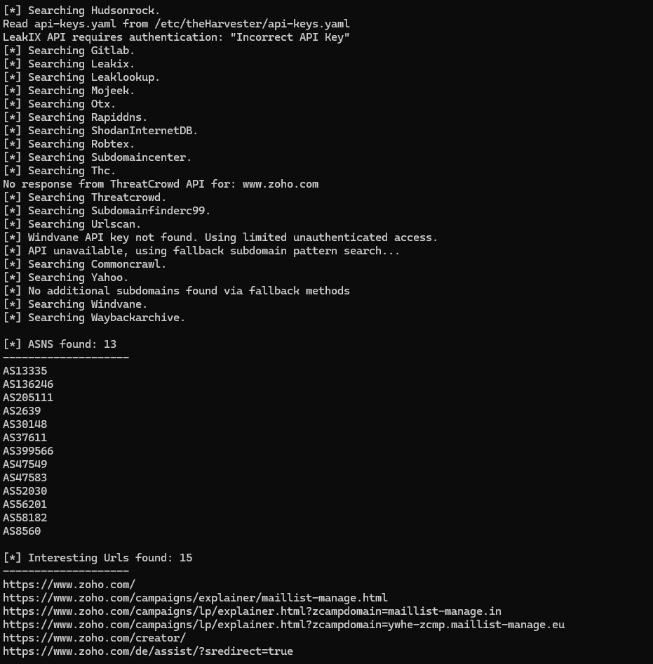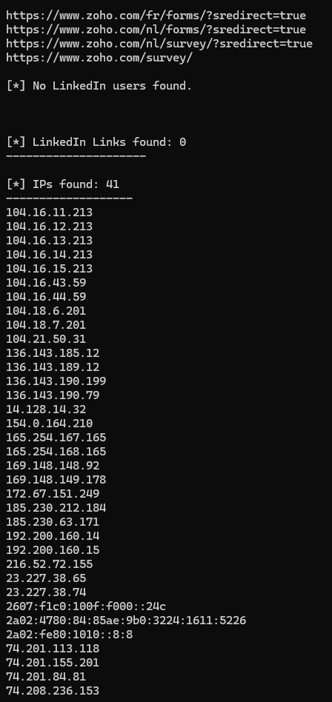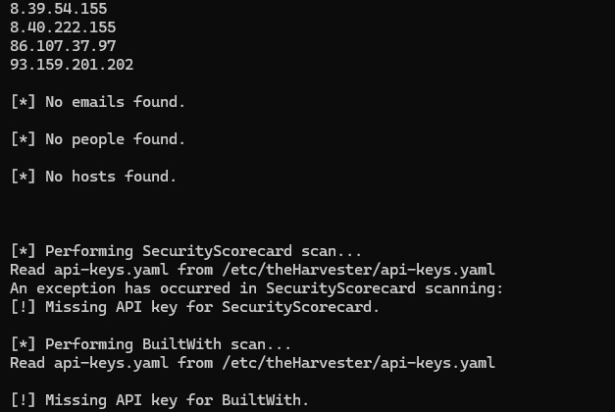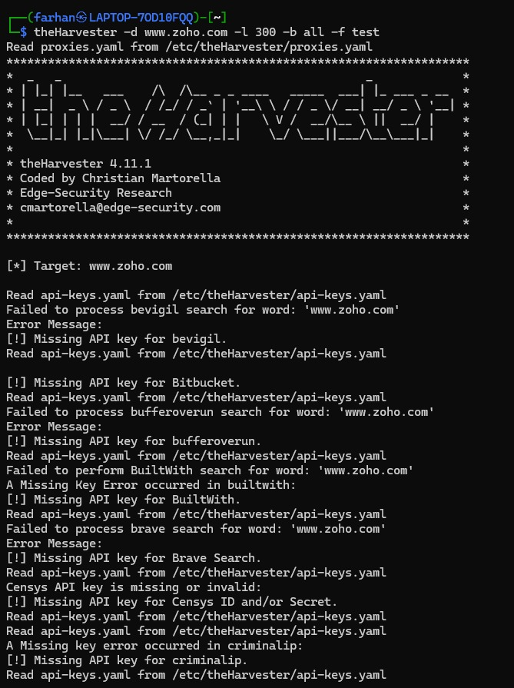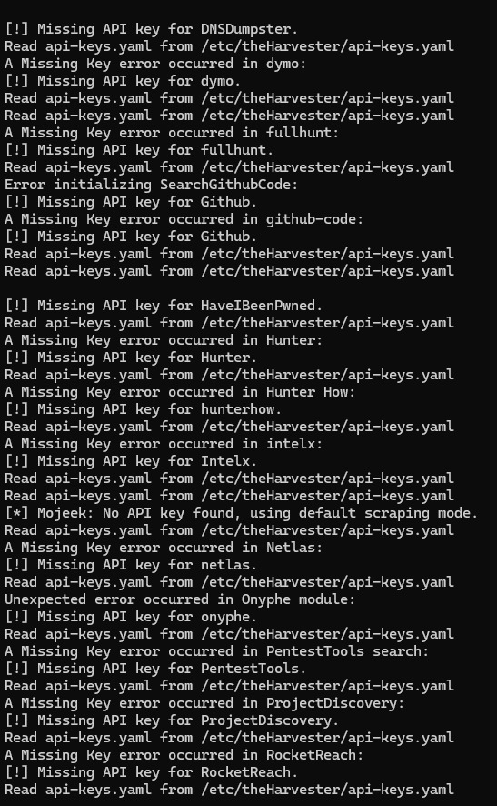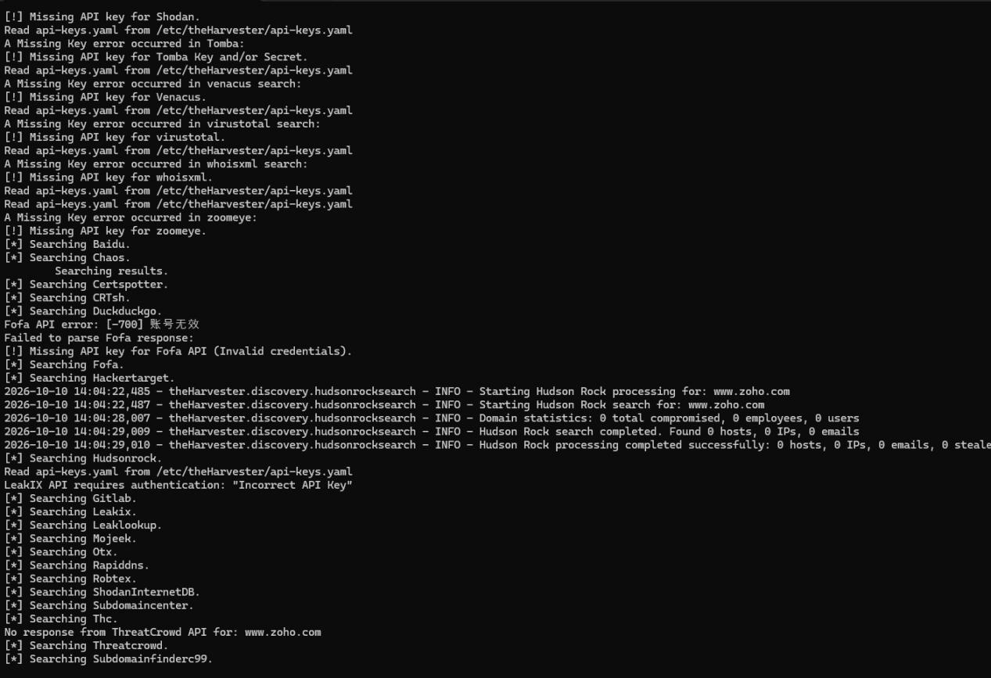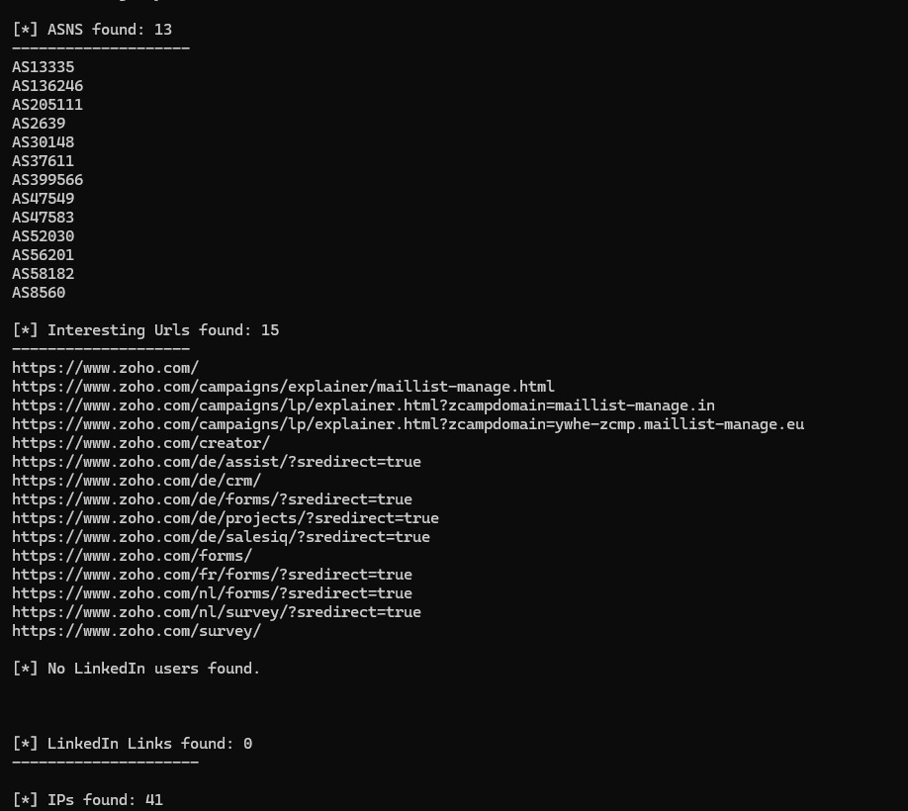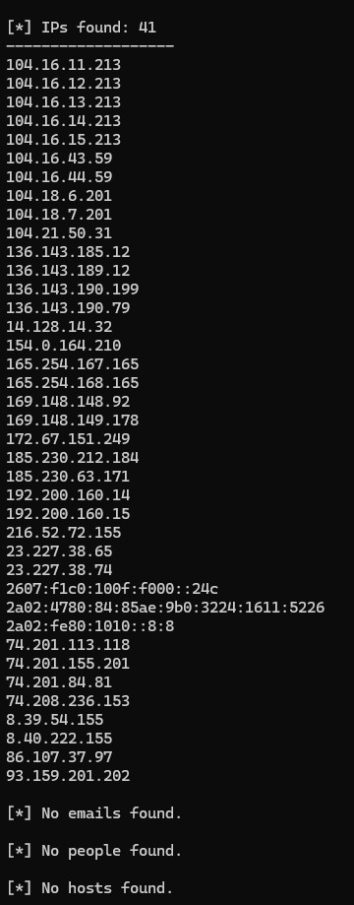

Result
Thus, information gathering was successfully performed using theHarvester, and publicly available information such as email addresses, hosts, and subdomains was collected from the authorized target domain.

